**Capstone Project**

Battle of Neighborhoods

(Week 1 Report)

By: Dennis Lam

# INTRODUCTION

Sandakan is located in state of Sabah, East Malaysia. It is the second largest town. The town was founded in 1878 and today has approximate 160000 residents staying in there.

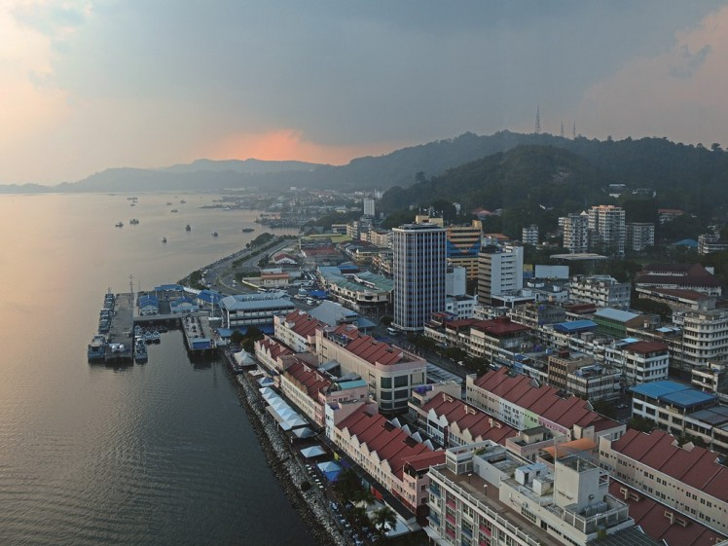

This Capstone project will try to find out where and which suburbs neighbourhood is suitable for setting up business.

# BUSINESS PROBLEM

As a town, the people here are mainly mid-income to low income earners, hence small type of businesses are more suitable instead of building large shopping malls.

We shall do an analysis of Sandakan neighborhoods and present the report which will consists of methodology, findings and conclusions.

Any person who wished to setup any new business can refer to this report which will be published in later period.

# DATA

The neighborhoods data is found in Sandakan Municipal website: <http://www.mps.sabah.gov.my/isandakan.cfm#penduduk>

The focus will be on these neighbourhoods (they are also called housing estates) around Sandakan. These people who stayed therein will be the main customer target for new businesses.

I will be using some Python libraries like pandas, geopy, folium, scikit-learn etc to explore and cluster these neighbourhoods to find out which one is suitable.

Foursquare APIs will be used to find out any interesting venues like food, offices, entertainment etc.

Google maps and Geopy library will be used to find latitude and longtitude for each neighbourhood as geolocation data is not available online.